**Autonomous Drone for Power Line Inspections**

System Requirements Document (SRD) Final

Version 2.0

December 3, 2018

**Acknowledgements:**

Sections of this document are based upon the IEEE Guide to Software Requirements Specification (ANSI/IEEE Std. 830-1984) and various other universities modifications of these requirements specifications were used as a guide in developing it for the course.

Team Member 1 Name: Talha Bin Amir

Signature:_____________________, date: ____12/1/2018_____

Team Member 2 Name: Joseph Ellis

Signature:___________Joseph Ellis________________ , date: _____12/3/18______

Team Member 3 Name: Adam Woughter

Signature:_____________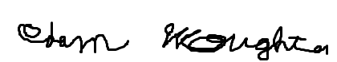_________ , date: ____12/1/2018_____

Team Member 4 Name: Brian Vu

Signature:______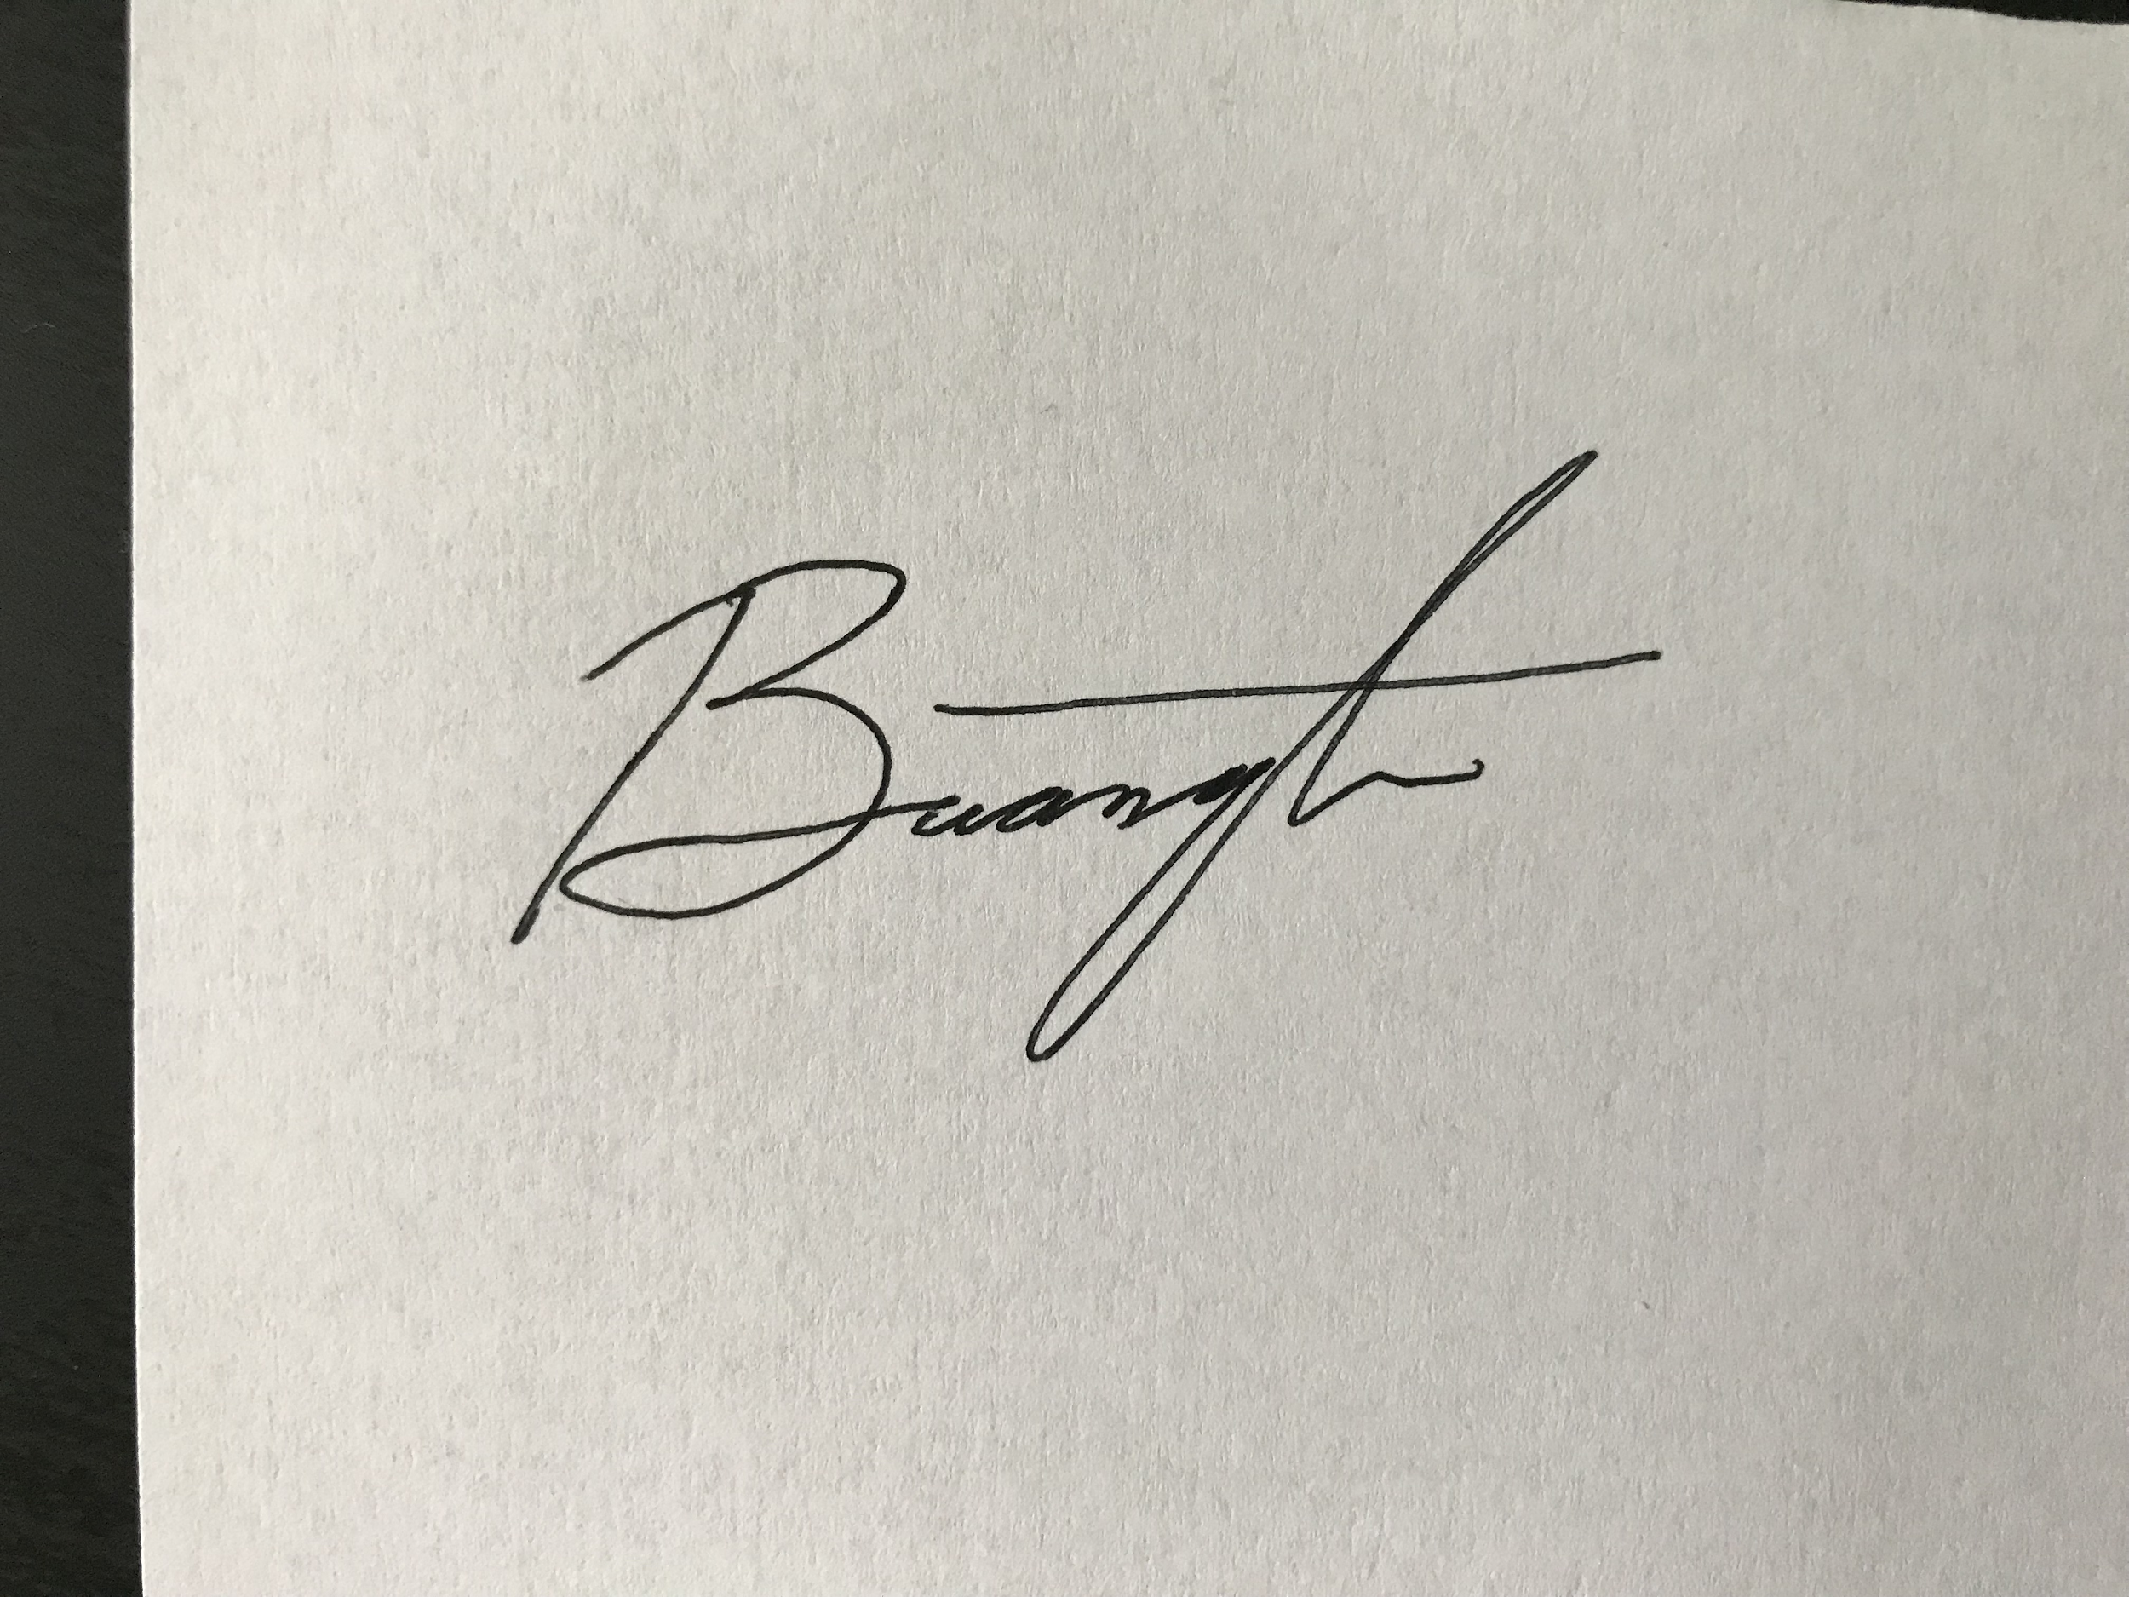______________________ , date: ___12/3/18_________

Faculty Advisor Name: Wilfrido Moreno

Signature:_______________________ , date: ____12/3/18________

Table of Contents

**1. Executive Summary** **4**

1.1 Project Overview 4

1.2 Purpose and Scope of this System Requirements Document 5

1.3 1.3 Definitions, Acronyms, and Abbreviations 5

**2. Product/Service Description** **6**

2.1 Product Context 6

2.2 Assumptions 6

2.3 Constraints 6

2.4 Dependencies 7

**3. Requirements** **7**

3.1 Following areas should be considered for Functional Requirements 8

3.1.1 User Interface Requirements 8

3.1.2 Performance 8

3.1.3 Availability 8

3.1.4 Manageability/Maintainability 9

3.1.5 Systems Interfaces 9

3.2 System Requirements Matrix 9

**4. User Scenarios/Use Cases** **11**

5.1 Sequence Diagrams 13

5.2 Data Flow Diagrams 14

5.3 State-Transition Diagrams 15

Hexacopter System Component diagram 15

Hexacopter High Level System Diagram 15

QuadCopter Wiring Component Level System Schematic: 16

5.4 SWaP (Size Weight and Power) 16

5.4.1 Size 16

5.4.2 Weight 16

5.4.3 Power 17

5.5 System Performance 17

**6. Requirements Test Matrix** **19**

Inspection 19

Demonstration 19

Test 20

Analysis 20

**7. Project Risk** **23**

**8. Standards** **24**

**9. Change Management Process** **25**

# **1. Executive Summary**

## **1.1 Project Overview**

A drone that can take off, fly a predetermined path, return back to home autonomously. The drone shall be capable of taking videos and thermal readings for electrical grid inspection. The drone shall also be able to operate in the rain and return to home autonomously when either the wind speed exceeds 20 mph or the battery level is at 50%.

The engineering team shall develop a functional drone, design and develop the hardware and simulate its program function. The framework and physical structure shall be bought premade. The team shall develop the program to instruct the drone’s flight controller to perform certain tasks such as starting from a certain trigger, returning to the home base after the battery reaches a certain percentage or if the wind speeds are too high. The program shall also make the drone fly a predetermined path to follow electric grids.

The Primary Goal of this project is to have the drone take off from home, fly a predetermined path along electric grid lines and return back to base. The drone shall be able to avoid objects while in the air (anti-collision) and be able to remain stable while in flight.

The Secondary Goals of this project are adding a thermal and visual camera for the inspection of the electric grid lines, adding either wireless charging or some sort of charging station at the home base where the drone will charge after landing. The drone shall use the thermal and visual cameras to take pictures every second and store them on an SD card on board for reviewing later. Another feature that might be added could be a cover that could make the drone waterproof so it may be operated in the rain.

## **1.2 Purpose and Scope of this System Requirements Document**

To give an overview of the project and system requirements.

## **1.3 1.3 Definitions, Acronyms, and Abbreviations**

ESC - Electronic Speed Controller

SDK - Software Development Kit

API - Application Program Interface

**1.4 References**

1. Quadcopter build information. Project YMFC - AL - The Arduino Auto-Level Quadcopter

<http://www.brokking.net/ymfc-al_main.html>

1. Flight Analysis Website. Multicopter. Lipo Battery Calculator. 2012.

<http://multicopter.forestblue.nl/lipo_need_calculator.html>

1. Other Resources:

# **2. Product/Service Description**

## **2.1 Product Context**

Despite the technology being very robust, drones applications have been rapidly expanding in the past years. Mainly in the way if interfacing with other devices. This drone in particular, will need to interface with a video imaging system. The camera sub-system will be entirely separate from the drone, only sharing a battery, and the 2 systems will need to communicate with each other. Outside of this, the drone will be almost entirely self contained. This images taken by the camera, will be filtered and analyzed later.

## **2.2 Assumptions**

We are under the assumption that ArduPilot software development will remain a free and open source platform to be working under. If this changes soon, then we will have to change to the DJI development platform.

## **2.3 Constraints**

United States flight regulations are where most of our constraints will arise. The first limit, is that our device is not allowed to exceed 50 pounds. While this is a very high ceiling it will still limit some designs, especially the tethered applications. Another constraint is that the device can not leave line of sight of the operator, despite this not limiting our design directly, it does remove many benefits of extending the communication range of the transmitter and receiver.

## 

## 

## **2.4 Dependencies**

The manual override feature will require somebody to be observing the drone during its entire flight.

# **3. Requirements**

Motor System:

* Achieve maximum achievable efficiency
* Log hours on motor performance (motor rotations) - to know when to replace
* Test by lab

Communication System:

* Communicate from transmitter to receiver without error and within range
* Test by lab/field

Flight Control System:

* Flight Controller performs software task perfectly.
* Software debugs,compiles, and runs without error
* Test by software

Battery System:

* Perform at maximum efficiency
* Charges at maximum capacity

## 

## **3.1 Following areas should be considered for Functional Requirements**

### **3.1.1 User Interface Requirements**

* User shall be able to set waypoints to determine the drone’s autonomous path
* User shall have the capability to override autonomous mode and assume manual control
* User shall have access to the documentation on this system
* System shall send alerts to the user if thermal readings are past a certain threshold

### **3.1.2 Performance**

* Using GPS and a gyroscope, the drone shall fly in an autonomous path with no more than 10 feet of error
* The drone shall use ultrasonic sensors to detect obstacles in front of it
  + The drone shall stop and change course upon detecting an obstacle
* The drone shall take thermal and optical images every one second
  + The system shall send these images to the control center and save them into an onboard SD card
* Upon reaching 60% battery, the drone shall return to “home base”
* Upon sensing winds exceeding 20 mph, the drone shall return to “home base”
* The drone shall be resistant to water

### **3.1.3 Availability**

* The drone shall be flown only during daylight hours (The system lacks the proper lighting to fly at night per FAA regulations)

### **3.1.4 Manageability/Maintainability**

* The user shall be given vendor information to source parts should they need replacements

### **3.1.5 Systems Interfaces**

* The flight controller shall interface with the ESC’s, transmitting speed information to the ESC’s by hardwire connection
* The ESC’s shall hardwire connect to the motors via three wires
* The ultrasonic sensor, GPS module and gyroscope shall connect to the flight controller via a hardwire connection

## **3.2 System Requirements Matrix**

Table 1 Requirements

|  |  |  |  |  |  |
| --- | --- | --- | --- | --- | --- |
| Req# | Function | Requirement | Comments | Date Rewd | SME /Faculty Reviewed / Approved |
| 0 | Wiring | All systems connected: Sensor, Battery, motor, ESC, flight controller, camera, frame, | Hardware | 12/3/18 |  |
| 1 | Checkpoints / waypoints | User shall set drone GPS waypoints. The waypoints/checkpoints determine the drone’s autonomous path | Autonomous System - GPS | 12/3/18 |  |
| 2 | Autonomous to Manual | User shall override autonomy and assume manual control | Communication System - Transmitter & Receiver | 12/3/18 |  |
| 3.1 | Camera Pictures | The user/drone shall take optical/thermal images every one second | Camera System | 12/3/18 |  |
| 3.2 | Save Pictures | The system shall save images into an onboard SD card | Camera System | 12/3/18 |  |
| 4 | Error Correction | Drone shall fly autonomous path with no more than 10 feet of error using GPS and a gyroscope | Flight Control System  Software - Ardupilot | 12/3/18 |  |
| 5 | Motor | The flight controller shall interface with the ESC’s and motors | Motor System | 12/3/18 |  |
| 6 | Low Battery Indicator | Upon reaching 60% battery, the drone shall return to “home base” | Battery System | 12/3/18 |  |
| 7.1 | Object Anti - Collision | The drone shall detect obstacles by ultrasonic sensors | Sensor System - Ultrasonic Sensor | 12/3/18 |  |
| 7.2 | Object Anti - Collision | The drone shall avoid object | Sensor System - Ultrasonic Sensor | 12/3/18 |  |
| 7.3 | Thermal Reading | System shall send alerts to the user if thermal readings are  past a certain threshold | Sensor System  For Future design | 12/3/18 |  |
| 7.4 | Thermal Reading | System shall send alerts to the user if thermal readings are  past a certain threshold | Sensor System  For Future design | 12/3/18 |  |
| 7.5 | Wind Indication | Upon sensing winds exceeding 20 mph, the drone shall return to “home base” | For future design | 12/3/18 |  |
| 8 | Water Resistance | The drone shall be water resistant | For future design | 12/3/18 |  |
| 9 | Flight Hours | The drone shall be flown only during daylight hours | Management - FAA regulations. | 12/3/18 |  |
| 10 | Equipment Maintenance | Vendor shall have parts list for equipment maintenance/replacements | Management | 12/3/18 |  |

# **4. User Scenarios/Use Cases**

· Describes a significant business need:

A drone that can take off, fly a predetermined path, return back to home autonomously. The drone shall be capable of taking videos and thermal readings for electrical grid inspection. The drone shall also be able to operate in the rain and return to home autonomously when either the wind speed exceeds 20mph or the battery level is at 50%.

· Identifies, documents, and ranks the problem that is driving the scenario

Inspecting a substation or electric grid is expensive because of the need of larger vehicles needed such as SUVS, helicopters, as well as deploying an line-man. The drone reduces the cost by troubleshooting without sending an employee out to the field and inspect at dangerous heights.

· Describes the business and technical environment that will resolve the problem

The drone will provide visual aid of the transformer/electrical grid for Florida Power & Light employees to analyze. The images captured during the drone flight, will be analyzed to determine whether a transformer/electrical grid is in healthy conditions.

· States the desired objectives

We want the drone to fly autonomously from point A to point B. The destination path will be predetermined by checkpoints (waypoints). The drone shall have anti-collision abilities. The drone shall be able to self stabilize autonomously. The drone shall be able to record images during the flight time. The drone may be able to controlled manually using a controller/transmitter.

· Shows the “Actors” and where they fit in the business model

The actors in the business models are the Florida Power & Light employees who will be flying the drone.

Test and Evaluation will be done by the drone team (USF students). The team will make sure the drone is safe to fly before deploying to field.

· Is specific, and measurable, and uses clear metrics for success

Before deploying the drone out to the field, the drone will be tested by the drone team. The motors will be tested to fly at a controlled speed/power. The maximum flight time will be determined by the battery, payload, and motor power/speed.

**5. Analysis Models**

## **5.1 Sequence Diagrams**



## 

## 

## 

## 

## 

## 

## 

## 

## 

## **5.2 Data Flow Diagrams**



## **5.3 State-Transition Diagrams**

### **Hexacopter System Component diagram**

## 

### **Hexacopter High Level System Diagram**



### **QuadCopter Wiring Component Level System Schematic:**

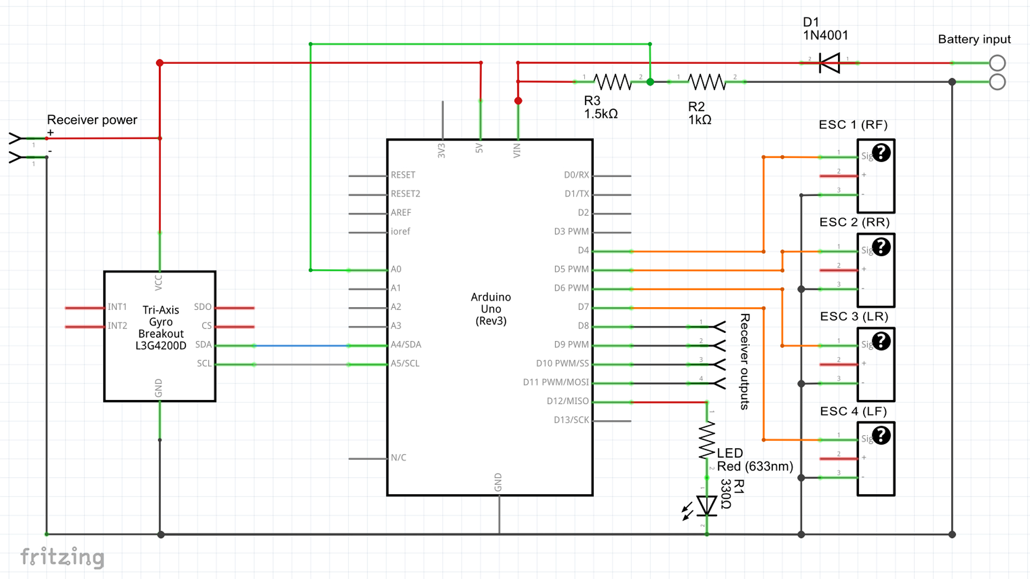

## **5.4 SWaP (Size Weight and Power)**

### **5.4.1 Size**

**Tarot T960 Hexacopter Frame**

|  |  |
| --- | --- |
| Arms diameter | 25mm = about 1 inch |
| Drone diameter | 960mm = 3.1 feet |
| * End to end | * 1000mm = 3.3 feet |
| * Center body dimension | * 210 x 210 x 2.0mm = 8 x 8 x 0.1 in |

### **5.4.2 Weight**

**Tarot T960 Hexacopter Frame & equipments**

|  |  |
| --- | --- |
| Frame weight | 1050g |
| All-up-weight | 4.3~4.5kg = about 10 lbs |
| Camera weight or GoPro weight Hero 3 | 700g |
| Flight controller weight: | 16g |
| Motor weight (total of 6) : | 215g = 0.5 lbs |
| ESC weight (total of 6): | 33g |
| Propeller weight (total of 6): | 26g |
| Battery weight: | 875g |
| **Total system weight:** | **2915g = 6.43 lbs** |

### **5.4.3 Power**

**Battery: 6S 22.2V LiPo, 5500mah for 8 minutes, 12000mah for 15 minutes**

|  |  |
| --- | --- |
| Battery capacity: | 7000mAh |

## **5.5 System Performance**

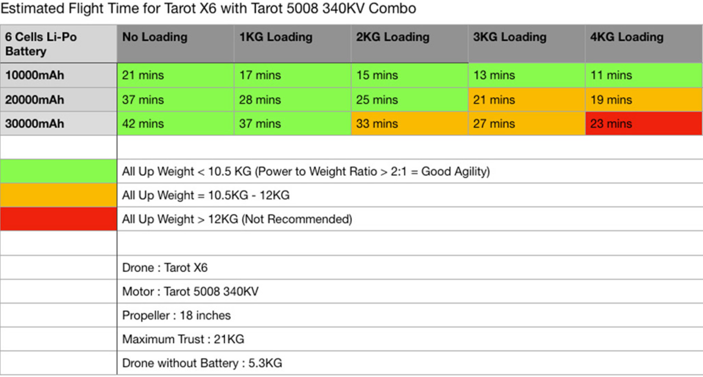

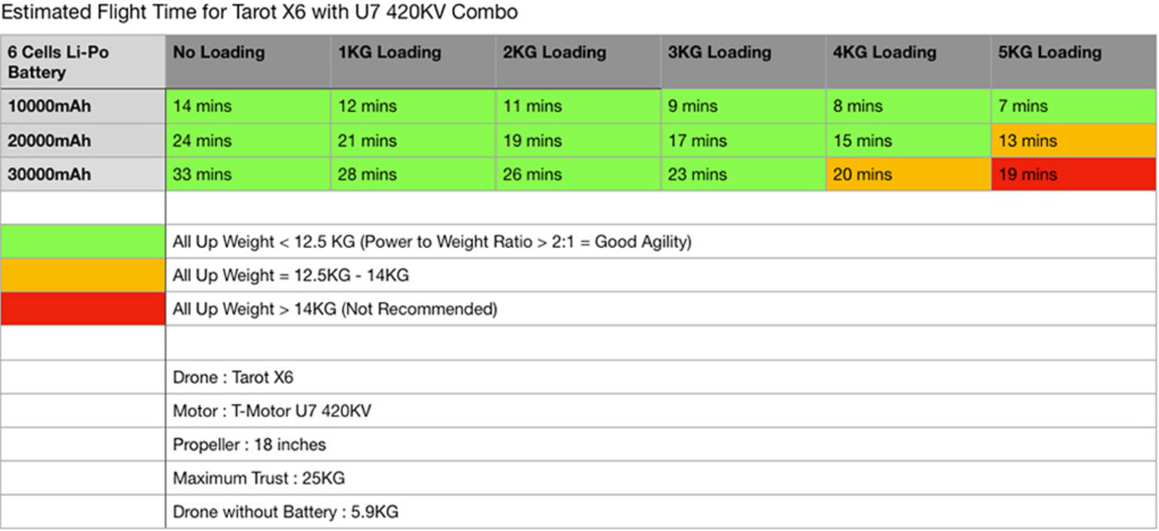

# **6. Requirements Test Matrix**

### Inspection

Inspection is observation using one or more of the five senses, simple physical manipulation, and mechanical and electrical gauging and measurement to verify that the item conforms to its specified requirements.

Communication Requirement: Range, Motor Response, Flight Controller response

* Receiver and transmitter complete motor tasks
* Receiver and Transmitter can receive data within range

Battery Requirement: Provides enough power to motor, flight controller, sensor, camera

* Battery will have full charge
* Battery will indicate when battery is at 60% battery capacity left
* Battery charger will fully charge battery at maximum capacity

Payload Requirement: Less than motor lift capability

* Double check if it is under the weight lift (motor performance)

### Demonstration

Demonstration is the actual operation of an item to provide evidence that it accomplishes the required functions under specific scenarios.

### Test

Test is the application of scientific principles and procedures to determine the properties or functional capabilities of items. Test is similar to demonstration, but is more exacting, generally requiring specialized test equipment, configuration, data, and procedure in order to verify that the item satisfies the requirement.

Motor Requirement:

* Motor will perform at maximum capacity thrust and maximum rotations per minute (rpm)

Software Requirement:

* Flight controller will perform all capabilities and functions without error

Communication Requirement: Range, Motor Response, Flight Controller response

* Receiver and transmitter complete motor tasks
* Receiver and Transmitter can receive data within range

### Analysis

Analysis is the use of established technical or mathematical models or simulations, algorithms, or other scientific principles and procedures to provide evidence that the item meets its stated requirements. As test was like a more involved version of demonstration, so analysis is like testing on steroids. In analysis, many tests may be performed, but the results of any given test do not give a pass or fail indication, rather all of the results must be taken in concert and we must perform some further operation in order to determine whether the item satisfies the requirement.

Table 2 Test Requirements Matrix

|  |  |  |  |  |  |
| --- | --- | --- | --- | --- | --- |
| Req# | Function | Requirement | Test Method | Brief Test description | SME /Faculty Reviewed / Approved |
| 0 | Wiring -  Hardware | All systems connected: Sensor, Battery, motor, ESC, flight controller, camera, frame, | Inspection |  |  |
| 1 | Checkpoints / waypoints - Autonomous System - GPS | User shall set drone GPS waypoints. The waypoints/checkpoints determine the drone’s autonomous path | Test in field |  |  |
| 2 | Autonomous to Manual - Communication System - Transmitter & Receiver | User shall override autonomy and assume manual control | Test in field |  |  |
| 3.1 | Camera Pictures - Camera System | The user/drone shall take optical/thermal images every one second | Test in lab |  |  |
| 3.2 | Save Pictures - Camera System | The system shall save images into an onboard SD card | Test in lab |  |  |
| 4 | Error Correction - Flight Control System  Software - Ardupilot | Drone shall fly autonomous path with no more than 10 feet of error using GPS and a gyroscope | Test in field |  |  |
| 5 | Motor | The flight controller shall interface with the ESC’s and motors | Test in lab |  |  |
| 6 | Low Battery Indicator | Upon reaching 60% battery, the drone shall return to “home base” | Test in lab |  |  |
| 7.1 | Object Anti - Collision | The drone shall detect obstacles by ultrasonic sensors | Test in lab/field |  |  |
| 7.2 | Object Anti - Collision | The drone shall avoid object | Test in lab/field |  |  |
| 7.3 | Thermal Reading | System shall send alerts to the user if thermal readings are  past a certain threshold | Test in lab/field |  |  |
| 7.4 | Thermal Reading | System shall send alerts to the user if thermal readings are  past a certain threshold | Test in lab/field |  |  |
| 7.5 | Wind Indication | Upon sensing winds exceeding 20 mph, the drone shall return to “home base” | Test in lab/field |  |  |
| 8 | Water Resistance | The drone shall be water resistant | Test in lab/field |  |  |
| 9 | Flight Hours | The drone shall be flown only during daylight hours | No Test |  |  |
| 10 | Equipment Maintenance | Vendor shall have parts list for equipment maintenance/replacements | No Test |  |  |

# **7. Project Risk**

1. Lose track of drone
   1. Obstacle collision
   2. “flyaway” event - bad communication connection may leave drone rogue
   3. ind/Weather affecting flight
   4. Mitigation plan: keep the drone in sight and in communication range
2. Battery run out during flight
   1. Mitigation: “Return home” protocols
3. Broken motor/ESC/drone parts
   1. Mitigation: buy extra parts
4. Scheduling/time/resources
   1. Meeting primary & secondary design goals
5. Security breaches of communications
   1. Jam communication
   2. Mitigation: shielding
   3. Likelihood: unlikely
6. Electromagnetic Interference
   1. From transmission lines
   2. Mitigation: Keep away at least 1 meter from the transmission line
   3. FAA Standard: DO-160G document - Electromagnetic Compatibility
   4. Use the ultrasonic sensor and code

# 8. Standards

1. USF Drone Policy and Form:
   1. Per [**USF System Policy 6-036**](http://regulationspolicies.usf.edu/policies-and-procedures/pdfs/policy-6-036.pdf) all users are required to receive approval from the appropriate area. Please follow the below instructions and complete the UAS process forms with all necessary information.
      1. <http://regulationspolicies.usf.edu/policies-and-procedures/pdfs/policy-6-036.pdf>
      2. <https://www.usf.edu/administrative-services/environmental-health-safety/drone-policy/procedure-forms.aspx>
2. FAA (Federal Aviation Administration) on Electromagnetic Interference
   1. Document: DO-160G. Equipment must be within 1 meter of radiating antenna (transmission) to be electromagnetically compatible.
   2. <http://everyspec.com/FAA/FAA-AC-PUBS/AC_21-16G_52821/>
3. FAA (Federal Aviation Administration) on flight proximity for commercial use:
   1. <https://www.faa.gov/news/fact_sheets/news_story.cfm?newsId=22615>

# **9. Change Management Process**

If in the event that we may need to change our project due project requirements or scope, we will consult our advisor: Dr. Wilfred Moreno, our team advisor: Robert Tuft, and our sponsor: Eric Schwartz. The team will submit such changes before making any agreement with any advisor or sponsor. The team will be responsible for building the project, therefore will have the final approval of any changes made. The project is for recreational/personal use and not meant for commercial use yet (stated by our sponsor: Eric Schwartz). These changes will be tracked and approved by the ConOps (Concept of Operations), SRD (system Reference Document), and PRD (Preliminary Design Review).